Guide to Texture by Feel

Modified from S.J. Thien. 1979. A flow diagram for teaching texture by feel analysis. Journal of Agronomic Education. 8:54-55. (Click here for a high-resolution version of the graphic.) http://soils.usda.gov/education/resources/lessons/texture/

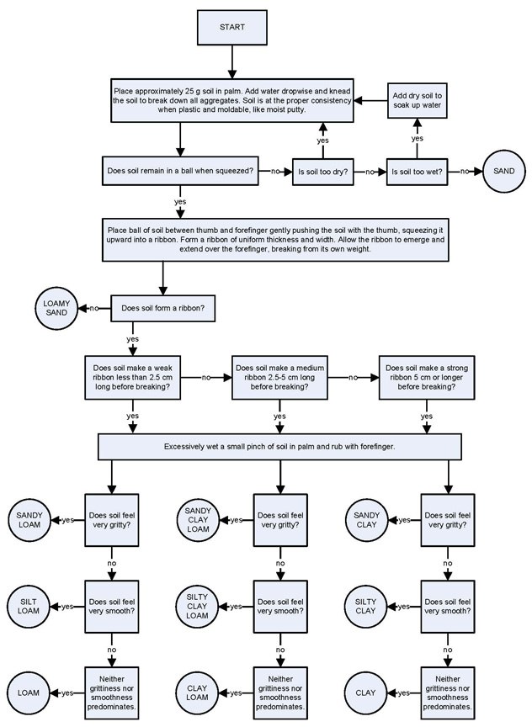
Texture class is one of the first things determined when a soil is examined. It is related to weathering and parent material. The differences in horizons may be due to the differences in texture of their respective parent materials.
Texture class can be determined fairly well in the field by feeling the sand particles and estimating silt and clay content by flexibility and stickiness. There is no field mechanical-analysis procedure that is as accurate as the fingers of an experienced scientist, especially if standard samples are available. A person must be familiar with the composition of the local soils. This is because certain characteristics of soils can create incorrect results if the person does not take these characteristics into account.
In some environments clay aggregates form that are so strongly cemented together that they feel like fine sand or silt. In humid climates iron oxide is the cement. In desert climates silica is the cement and in arid regions lime can be the cement. It takes prolonged rubbing to show that they are clays and not silt loams.
Some soils derived from granite contain grains that resemble mica but are softer. Rubbing breaks down these grains and reveals that they are clay. These grains resist dispersion and field and laboratory determinations may disagree.
Many soil conditions and components mentions earlier cause inconsistencies between field texture estimates and standard laboratory data. These are, but not limited to, the presence of cements, large clay crystals, and mineral grains. If field and laboratory determinations are inconsistent, one or more of these conditions is suspected.

Soil Textural Triangle
Click here for a high-resolution version of the graphic.
